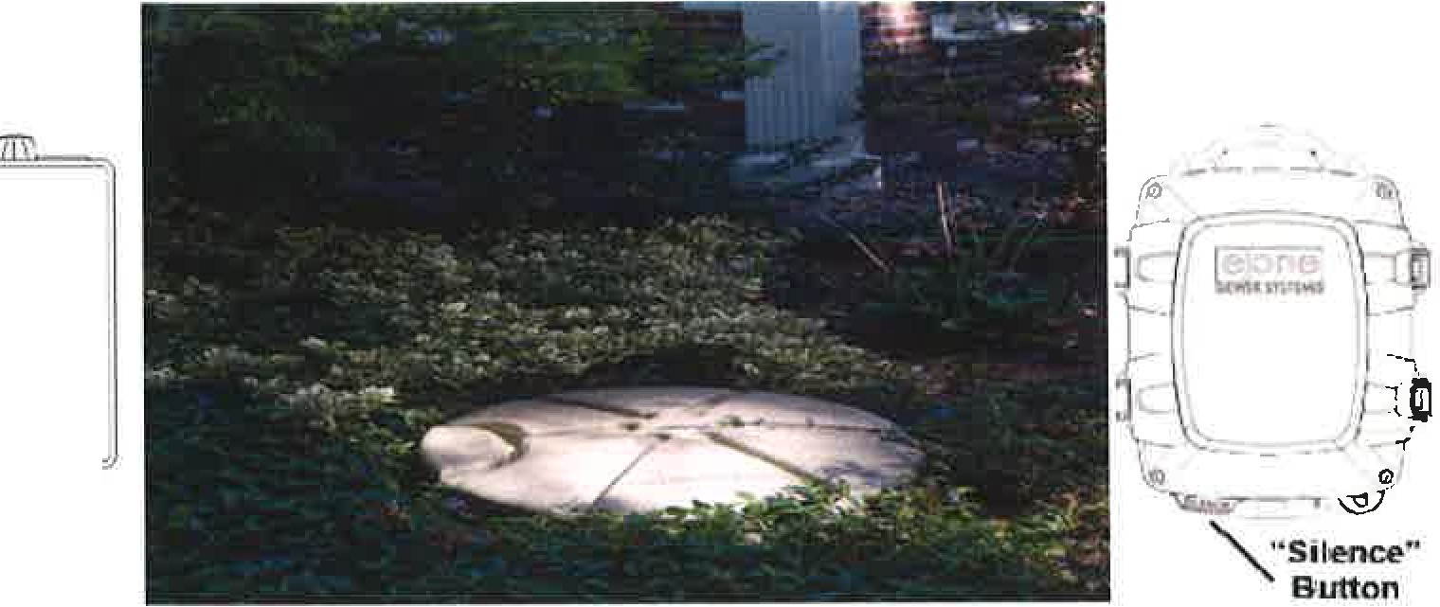East Marlborough Township Grinder Pump Information

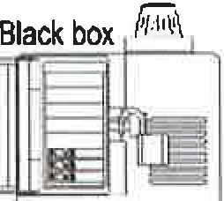
Gra box

The "Silence• button is localed on the lower- leflhand oomer of the panel box.
)'""

24 Hour SEWER EMERGENCY Phone Number: 610-444-1594
PERMITTED MATERIALS: Human waste & toilet paper, wastewater from sinks, showers, tubs, dishwashers, clothes washing machines.

NEVER FLUSH OR DUMP THE FOLLOWING MATERIALS DOWN THE DRAIN:

WIPES of any kind, even if listed as "flushable". They do not deteriorate and can build up and cause a blockage or damage the pump.
GREASE/ OIL from cooking will solidify, accumulate, and eventually restrict or completely block the pipe and or pump. SOLIDS such as glass, metal, gravel, sand, seafood shells, plastic, kitty litter, disposable diapers, feminine products, etc. SOLVENTS, PAINT, GASOLINE, OIL, ANTI-FREEZE, OR OTHER HAZARDOUS SUBSTANCES will cause harm to the
environment and certainly damage the pump.

WHAT TO DO WHEN THE ELECTRICTV GOES OUT:

LIMIT YOUR WATER USAGE AS MUCH AS POSSIBLE! The grinder pump tank should have enough storage capacity for about 30 gallons of wastewat er. The high water alarm will not function without electricity, so occupants need to be aware of the possibility of wastewater backing up into the home if they aren't limiting the water usage during the power outage.

/ Many of the newer grinder pumps were installed with a Remote Sentry alarm that is battery operated, and will activate when the water level reaches high level, even when the power is out. The units were commonly installed near the main electric service panel inside the house. These units should be tested on a regular basis, and batteries replaced if needed, much like a smoke detector. They require 4 lithium batteries, CR2032.
PLEASE REMEMBER THAT IT IS THE RESIDENT'S RESPONSIBILTY TO KEEP THEIR GRINDER PUMP STATION EXPOSED AND ACCESSIBLE FOR EMERGENCY SERVICE .

If you have questions or would like more information about your grinder pump system, call us at 610-444-1375.

