2018 General Fund Draft Budget as of 12/1/2017

Income

2018

Rt._, Estate Tax $ 738,700.00
Liened tax $ 20,000.00
Public Utility Realty Tax $ 2,150.00
Local Services Tax $ 180,000.00
Hydrant Tax $ 50,000.00
Light Taxes $ 4,000.00
Property Transfer Tax $ 250,000.00
Subdivision and Land Dev. Fees $ 15,000.00
Hearing Fees $ 9,500.00
Fines $ 12,000.00
Police Income $ 72,000.00
Leases $ 185,000.00
Cable Franchise Fee $ 185,000.00
Liquor Licenses $ 1,600.00
Miscellaneous Income $ 24,000.00
Building Permits $ 90,000.00
Zoning Permits $ 12,000.00
PennDot Snow/Ice $ 17,000.00
Pension/State Aid $ 34,997.00
Sewer District Reimbursement $ 175,000.00
1eering/legal reimbursement $ 160,000.00
Interest $ 10,000.00
Balance previous year $ 202,304.61
Total Income $ 2,450,251.61
2017 Assessed value - $699,000,000 2018 Assessed value - $703,970,300

Expense
Open Space Tax - 301.6 $ 140,600.00
library Tax - 301.7 $ 128,649.00
Fire Distribution 301.10 $ 474,879.00
Emergency/ Ambulance 201.11 $ 52,764.33

2018

Governing Administration $ 17,200.00
Administrative Salaries $ 121,500.00
Professional Fees $ 71,500.00
Other general administration $ 21,150.00
Computer/IT Expenses $ 10,000.00
Engineering/Planning $ 265,000.00
Building Inspection $ 85,000.00
ling Utilities $ 21,650.00
Building Maintenance/Repair $ 152,000.00

Property Taxes Police Payroll
2018 General Fund
Draft Budget as of 12/1/2017
$ 13,500.00
$ 226,454.84
$ 1 2,000.00
$ 16,000.00
$ 4,500.00
$ 45,000.00
$ 81,000.00
$ 2,800.00
$ 1,000.00
$ 292,943.04
$ 45,000.00
$ 19,040.00
$ 1,500.00
$ 37,500.00
$ 5,000.00
$ 5,000.00
$ 5,000.00
$ 15,000.00
$ 600.00
$ 91,750.00
$ 68,822.00
$ 74,421.00
$ 130,907.00
$ 60,763.78
$ 175,000.00
$ 51,999.95
$ 202,750.00
$ 2,450,251.61

p Operations
f- -e Office Expenses Police Vehicles
Hydrants
Hearing Expenses
SPCA
Hazardous Waste Collection Public Works Payroll Garage Vehicles
Garage Operations
Vegetation Management Traffic Control
Ice/Snow Removal Unionville Street Lights
Storm sewers and drains Curb repair
Tools and Machinery Roads
Commercial Insurance
Workmen's Comp Insurance Health Insurance
r ·ement
<.:i....,eraI Fund - Sewer/Water
Payroll Expenses Year End Carryover

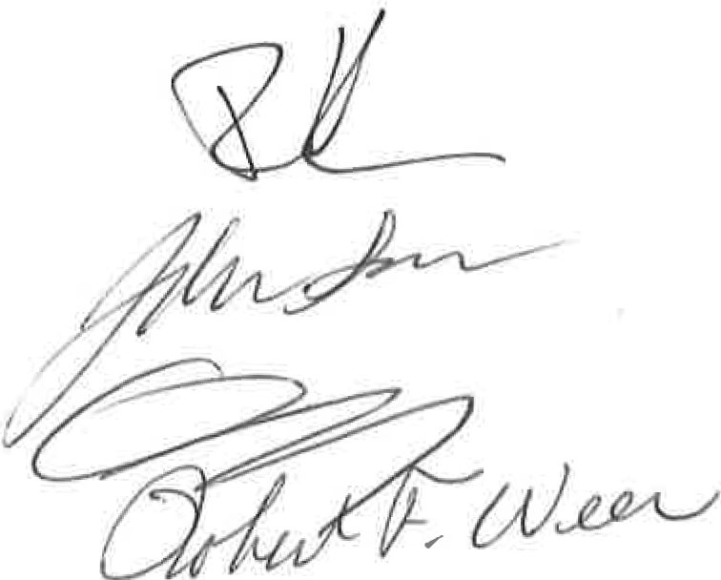

2018 Sewer Fund Proposed Budget

SEWER BUDGET  RECEIPTS | DRAFT as of 12/1/2017  2018
User fees | $978,280
Tap Fees | $168,000 (21 tapping fees)
Loan Repayment - Rt 82 finance | $15,000
Interest | $160
Grinder Pump reimb | $6,000
Sludge/sewage Disposal Operating Reserve | $12,000  $1,179,440
260 EDU's @ 840 | $218,400
1727 EDU's@ 440 | $759,880

Expenses
Chester Water | $600
Sludge Disposal
Lab Analysis | $30,000
Disinfection (Chlorine) | $20,000
Engineeri ng/LegaI | $15,000
Eng. Chap 94 | $1,000
Grinder pumps - repair | $45,000
Supplies | $5,000
Repairs/Maintenance - General | $47,500
Electric | $120,000
Phone Service | $3,500
Field Maintenance | $7,500
Bond Payment | $596,433 | $489,566.25 due on 12/1/17
Bond costs
Admin Fee (includes labor) | $150,000
I& !Study/correction
Vehicle Purchase
Operating Capital Reserve | $137,907
Capital Fund
Total | $1,179,440

Route 82 $840/Yr . All other Districts $440/yr

